University of Dayton

ECE

Mumma Radar Lab

Comprehensive VHDL

Fall 2016

Homework 2

Rotator

Purpose:

In this design you will be practicing IF statement, CASE statement, concatenation, and shift operation.

Design:

Design a 4 bit left/right rotator that can perform following operation:

* Enable or disable the rotation.
* Rotate left or right
* Rotate N bit

Your entity should look like this:

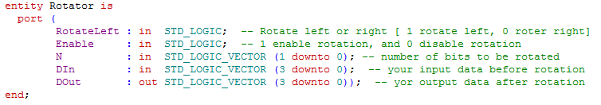

Your testbench should be self-checking. That is mean your testbech should read your design’s output and compares it to an expected result. For example:



More details in the class.

1. 5 MHz with 50 % duty cycle
2. 5 MHz with 75 % duty cycle
3. 5 MHz with 25 % duty cycle
4. 10 MHz with 50 % duty cycle

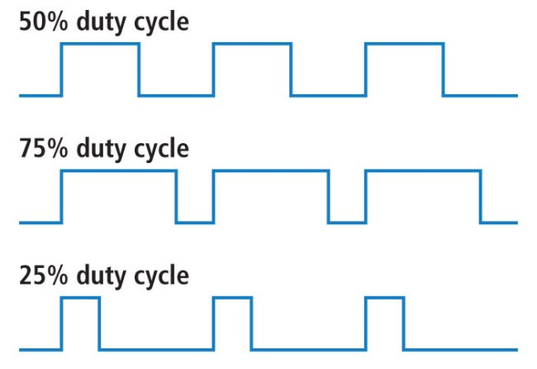

The user should be able to select between the 4 frequencies at any time.

Your entity should look like:

